API TESTING USING POSTMAN

- What is API Testing?
API testing is the way of communication between the two application. It act as the intermediate between presentation layer and database layer.
So instead of testing the wen application we directly send the request to API and get the response and we can test the response .

Client server architecture

1-tier architecture
In 1-tier architecture, the presentation, business logic, and data layers are all stored on a single device or a shared storage device. A good example is a desktop application that works offline and stores all its data on the same device it’s running from.

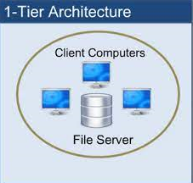

2-tier architecture
In 2-tier architecture, the presentation and business logic layers are stored on the client while the data layer is stored on a server. So as long as the code of an application is fully executed on the client and some of the data is being stored in a remote database, that application fits the 2-tier architecture criteria. A desktop application that requires you to log into an online account is a good example.

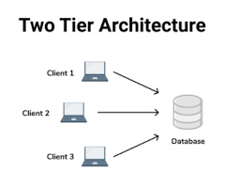

3-tier architecture
The presentation layer is stored on the client, the business logic layer is stored on one server, and the data layer is stored on another server. For example, you use a smartphone app’s user interface to interact with an app while an application server executes most of the app’s code and a database server stores the data.
